DS 522 Data Acquisition and Analytics
HOS10A - Time Series Basics
10/30/2025 Reviewed by Ashwin Paturi
04/07/2026 Reviewed by Vishal Krishna Kumar
05/28/2026 Reviewed by Namrata Mali

School of Technology & Computing (STC) @ City University of Seattle (CityU)

Take Note Before Starting
- The directory path shown in screenshots may be different from your directory.
- Not every step is explained in the tutorial. If you are not sure what to do:
  - Consult the resources listed below.
  - If you cannot solve the problem after several attempts, email your course TA for help.
Learning Outcomes:
- Understanding time series data.
- Understand how to create datetime and timestamp objects.
- Understand time-based indexing.
- Applying different and useful functions to time series data.
- Visualizing time series data
Resources
- McKinney. (2022). Python for Data Analysis (3rd edition).
- Tirendaz AI. (2021). Time Series with Pandas in 7 Minutes. Medium. https://levelup.gitconnected.com/time-series-basics-with-pandas-f74cab9923bb
- GeeksforGeeks. (2024). Basic Time Series Manipulation Using Pandas. https://www.geeksforgeeks.org/pandas-time-series-manipulation/ https://www.tutorialspoint.com/python_pandas/python_pandas_groupby.htm

Getting Started
- Open the VS Code and, within the VS Code, open the DS522 course folder created earlier. On the menu tab, select File, then Open New Folder. Navigate to your work directory or to the GitHub repository you cloned.
Example: C:\ Desktop\DS522 OR C: \Desktop\DS522\github_repository_name
NOTE: If you have cloned a GitHub repository that is explicitly provided for this course, navigate to that directory, and skip steps 2 to 4. This will be the folder where you will be storing all your HOS10A work.
- Once in your work directory, go to the menu tab again, select Terminal, select New Terminal to open a Command Line Interface (CLI) like the Command Prompt or PowerShell for Windows OS.
- Inside your “DS522” directory, create a new directory and name it “HOS10A”. Use the following command: >mkdir HOS10A
- Move to the new directory. Use the following command: >cd HOS10A
NOTE: This will be the folder where you store all your HOS10A work.
Time Series Data
Anything recorded repeatedly over many points in time forms a time series. Time series data is an essential form of structured data across many fields, including finance, economics, ecology, neuroscience, and physics. Many time series are fixed-frequency, meaning that data points occur at regular intervals according to a rule, such as every 15 seconds, every 5 minutes, or once per month. Time series can also be irregular without a fixed unit of time or offset between units.

How you mark and refer to time series data depends on the application, and you may have one of the following:
- Timestamps - specific instants in time.
- Fixed periods - includes the whole month of January 2024, or the entire year 2025.
- Intervals of time, indicated by start and end timestamps. Periods can be thought of as exceptional cases of intervals.
- Experiment or elapsed time - each timestamp is a measure of time relative to a particular start time (e.g., the diameter of a cookie baking each second since being placed in the oven), starting from 0.

The simplest kind of time series is indexed by a timestamp. Pandas provide many built-in time series tools and algorithms. You can efficiently work with large time series, slice and dice, aggregate, and resample irregular- and fixed-frequency time series.

Python’s DateTime: The datetime module in Python is part of the standard library and provides classes for manipulating dates and times. The datetime.datetime class is one of the most used classes in this module, allowing you to work with both dates and times together.
Common Use Cases:
- Storing and retrieving timestamps: Useful for logging, databases, and applications where precise timing is essential.
- Date and time calculations: Handling deadlines, schedules, or durations between events.
- Formatting dates and times: Converting datetime objects into human-readable strings for reports, logs, or user interfaces.
- Timezone-aware operations: Dealing with global applications where time zones are critical.

Key Features of datetime.datetime:
- Creating datetime Objects: A datetime object can represent a specific point in time, down to microsecond precision. You can create a datetime object using the datetime () constructor, specifying the year, month, day, hour, minute, second, microsecond, and time zone (optional).
- Attributes of datetime Objects: A datetime object has several attributes that allow you to access its components:
  - year, month, day
  - hour, minute, second
  - microsecond
  - tzinfo (if the object is timezone-aware)
- In your HOS10A folder or repository, create a new file by clicking File on the top menu bar, then New File, and selecting the Jupyter Notebook option. Save the file with CTRL + S, rename it to time_series.ipynb.
- Type the following code and run the code cells to load and see the data that we will be working on:

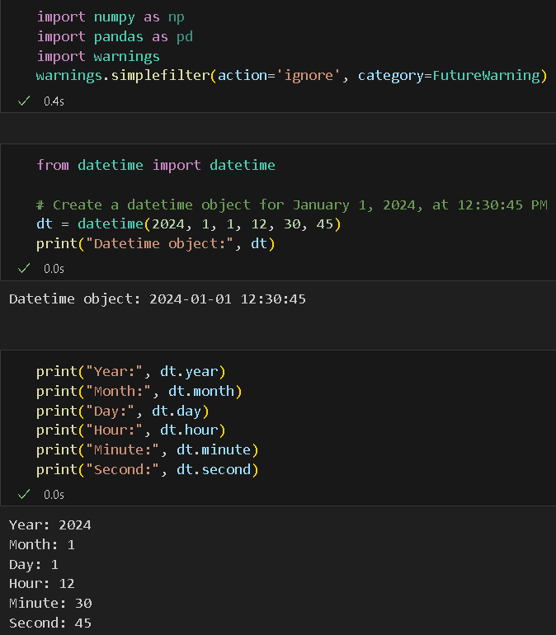

- Current Date and Time: Use datetime to get the current date and time.now()or datetime.today().

- Type the following code in a new code cell, then run it to see the results:

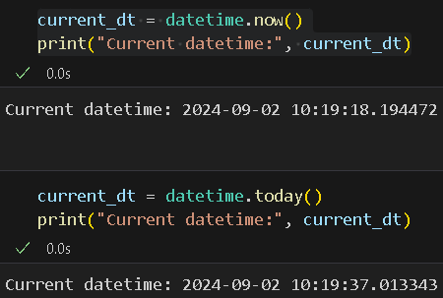
- Date Arithmetic: datetime supports arithmetic operations, allowing you to add or subtract time to/from a datetime object. We can use timedelta objects to perform these operations.

- Let us perform basic date arithmetic operations. Enter the following code in the new code cell and run it to observe the results:

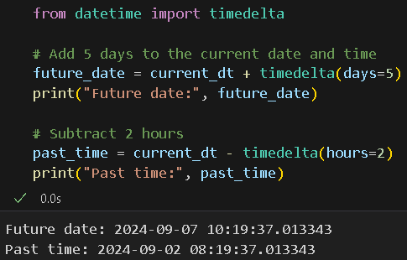
- Formatting and Parsing: The strftime() method allows you to format a datetime object into a string using a format specifier. The strptime() method allows you to parse a string into a datetime object using a format specifier.

- Let us perform some formatting and parsing. Type the following code in a new code cell and run it to see the output:
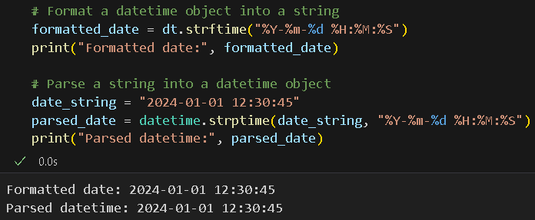

Pandas for Time Series Data
Pandas has a robust, flexible data structure that is extremely useful for time-series data. Pandas’ library has plenty of valuable tools often used for time series analysis. Pandas can easily substitute datetime objects, since its time-series tools are designed to be compatible with datetime. These tools are handy when the data is timestamped.

Timestamp objects are the Pandas equivalent of Python's datetime object. It is used for entries that make up a DatetimeIndex and for other time-series-oriented data structures in Pandas. The simplest time series is the Series structure indexed by timestamp, which is the most commonly used in pandas.series are also applicable to pandas.DataFrame.

- First, let us see how we can convert dates of different formats into a Pandas’ DatetimeIndex object. Type the following code in a new code cell and run it to see the output:

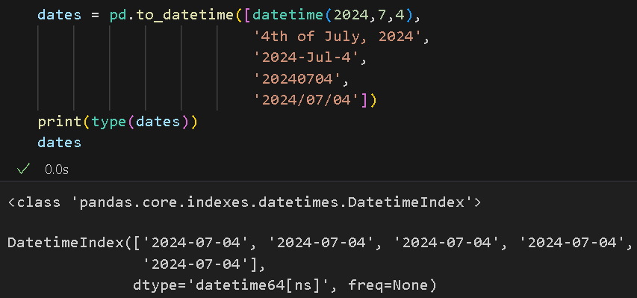

- Now, let us create a simple time series. Type the following code in a new code cell and run it to see the output:

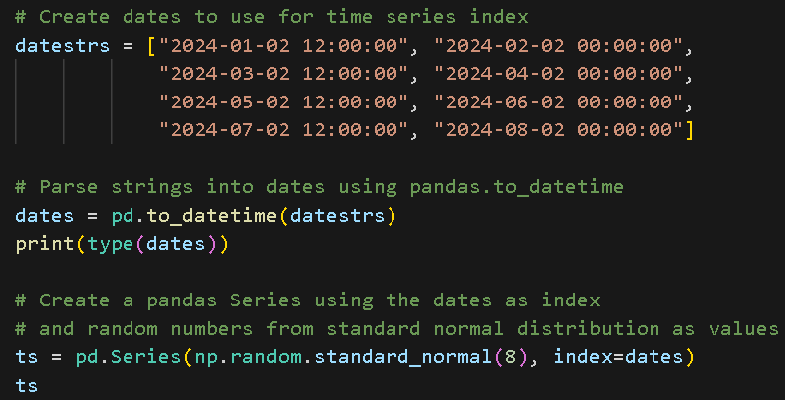
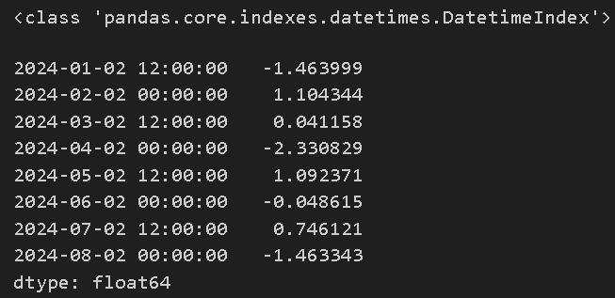

Take note: although using pd, the series will automatically parse string dates into a DatetimeIndex; we still use pd.to_datetime. This shows you how to parse strings into pandas’ DatetimeIndex. Commonly, you will be using data from various sources, and the formatting is quite different, so it is advisable always to parse date columns. pd.to_datetime is the easiest way to do that and is commonly used.

- Now, let us look at the index of our time series. Again, type the following code in a new code cell and run it to see the output:
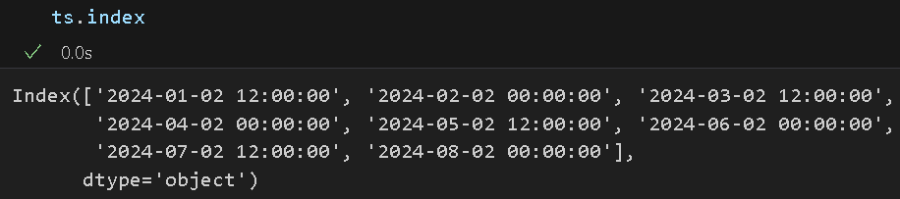
- This time, let us use real-world stock data. Create another Jupyter notebook and save it as ‘stock_ts.ipynb’. We will start by installing the Yahoo Finance Module, which allows us to retrieve data on different companies' stocks. Type the following code in a new code cell and run it to install the yfinance module:

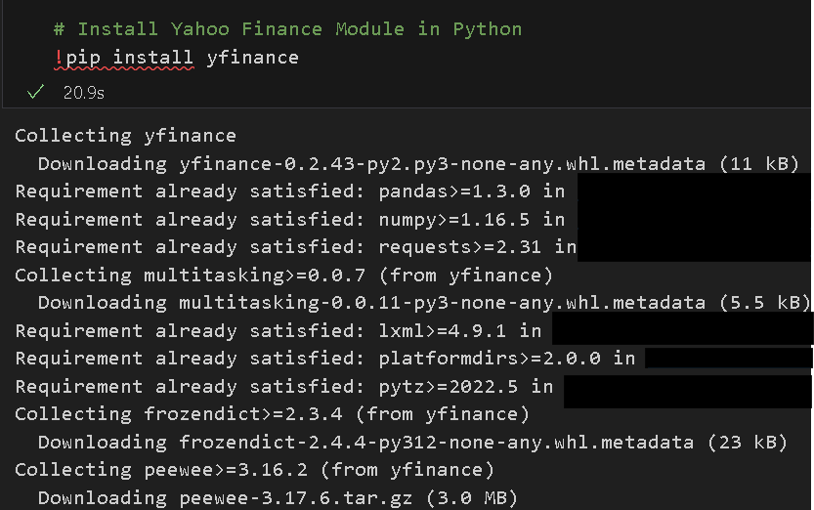

Make sure you will see this all the way at the bottom of the cell output:

- Now, let us retrieve Meta’s daily stock data. Type the following code in a new code cell, then run to see the output:
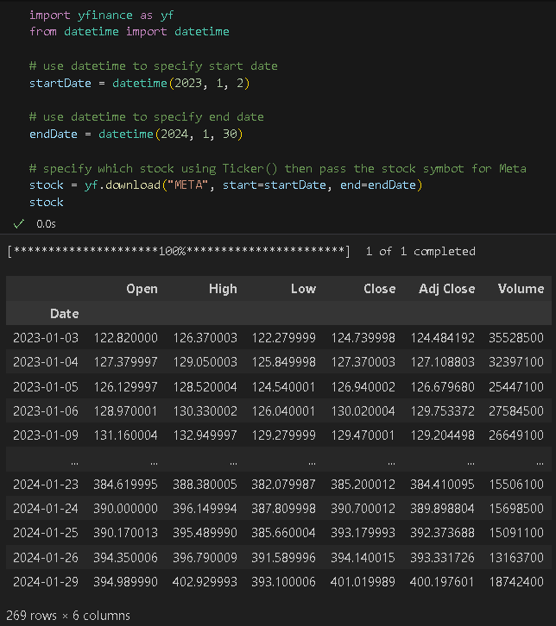

- Let us make sure we do not have any missing values and see more information about the data. Enter the following code in a new code cell and run it to observe the output:
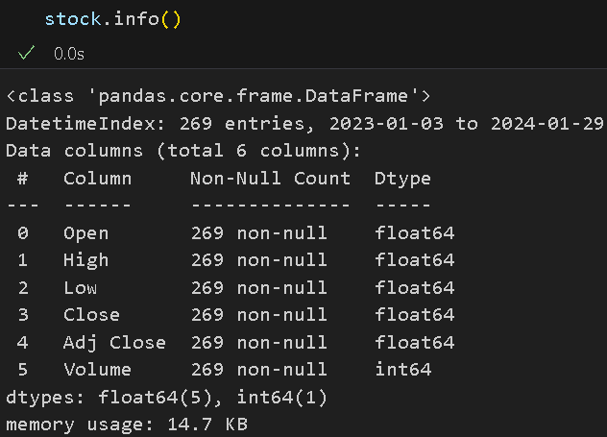

As shown in the Non-null Count, there is no missing data, as all entries per column are 269.

- Let us see the index of the stock data. Type the following code in a new code cell and run it to see the output:

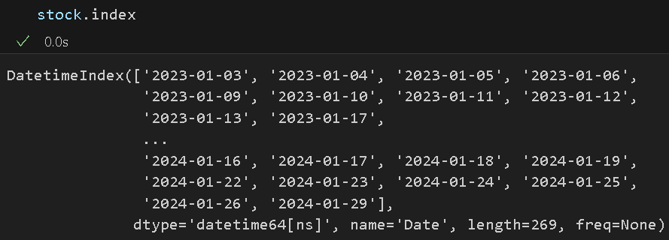

The data’s index is already a DatetimeIndex, so there is no need to parse it; otherwise, we can execute this code:

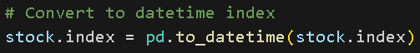

Indexing, Selection, Subsetting: Time series behaves like any other Series/Dataframe when you index and select data.

- Let us select a subset of our stock data. Type the following code in a new code cell, then run to see the results:

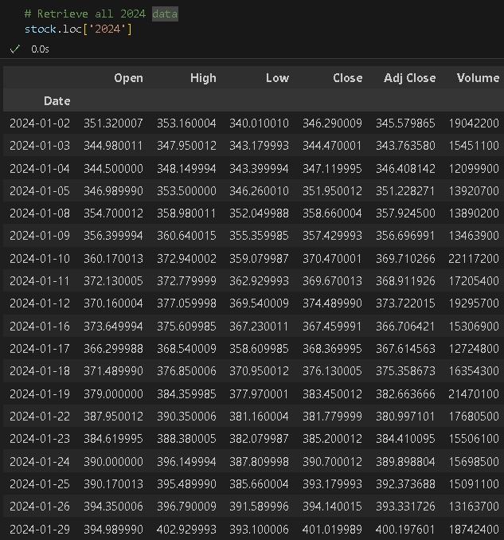

- Let us also check for duplicated indices using is_unique(). Type the following code in a new code cell, then run to see the output:

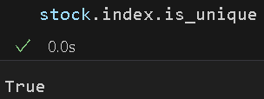

Date Ranges, Frequency, and Shifting - Date range: pandas.date_range generates a DatetimeIndex of the specified length at the selected frequency.

- We can use the date range object to filter in data that falls within the date range. Type the following code in a new code cell and run it to see the output:

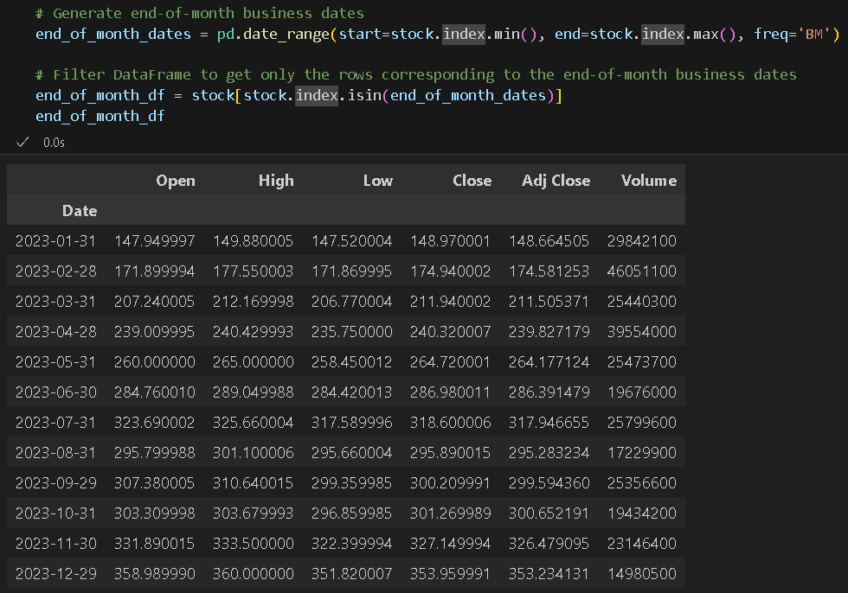

In this code, we passed several arguments to effectively filter the data and retrieve only those that meet the specified criteria. We used the index.min() and index.max() functions to retrieve the start and end dates, and then the freq=’BM’ to only get the last business day of each month.

We then use the resulting date range to get the stock data whose indices fall within those dates.

Shifting (Leading and Lagging) Data: Shifting refers to moving data backward and forward through time. Both Series and DataFrame have a shift method for performing naive forward or backward shifts, leaving the index unmodified.

- Type the following code in a new code cell and run it to see the output:
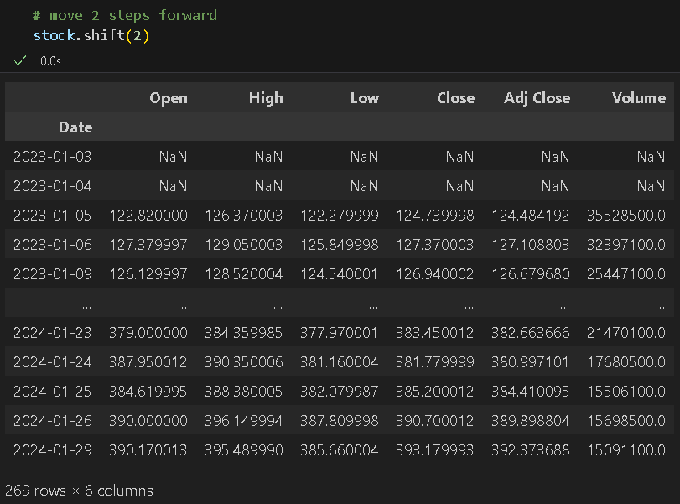

Here, because we shifted the data 2 steps forward, we introduced NaN values to the first rows.

- Let us shift backward this time. Type the following code in a new cell then run to see the output:

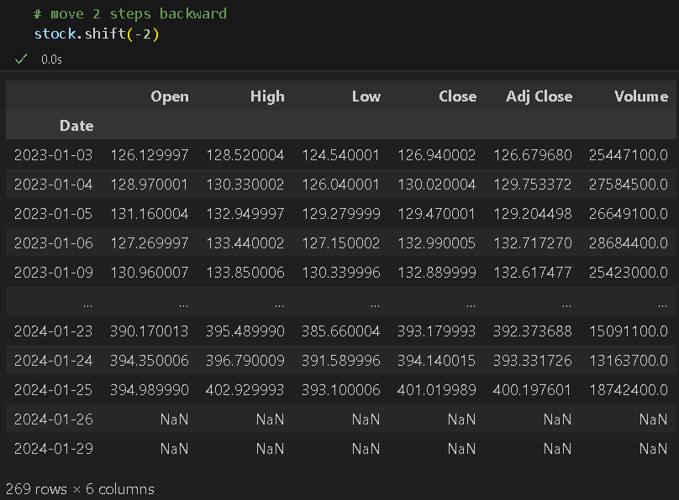
Similarly, we got NaN values in the last 2 rows as we shifted backward. Note the changes in the values after the 2 shift operations. Because naive shifts leave the index unmodified, some data is discarded. Thus, if the frequency is known, it can be passed to shift to advance the timestamps instead of simply the data:

- Type the following code in a new code cell and run it to see the output:

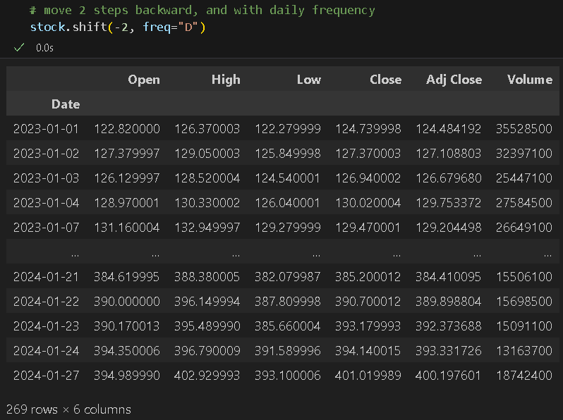

Here, after the shift, Pandas automatically removed the last two rows with NaN values. Take note of the date index and compare it with the original data.

- Another option for handling missing values after shifting is filling them. Type the following code in a new code cell and run to see the output:
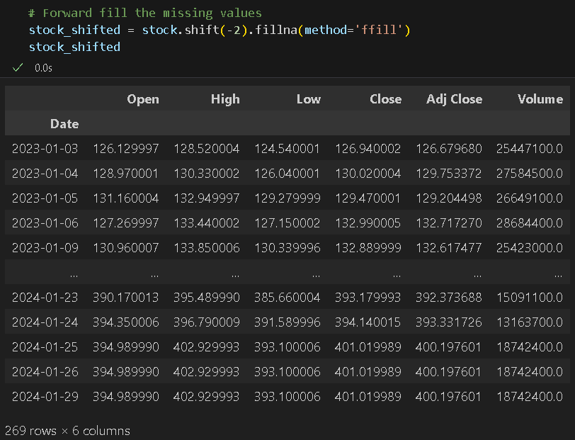

In this case, the date indices are unchanged, the values are shifted 2 steps backward, and the missing values in the last 2 rows are filled with the previous non-null value.

Resampling and Frequency Conversion
Resampling refers to the process of converting a time series from one frequency to another. Aggregating higher-frequency data to lower frequency is called downsampling, while converting lower-frequency data to higher frequency is called upsampling. Not all resampling falls into either of these categories; for example, converting W-WED (weekly on Wednesday) to W-FRI is neither upsampling nor downsampling. Pandas objects have a resample() method, which is the workhorse for all frequency conversion. Resample has a similar API to groupby; you call resample to group the data, then call an aggregation function.

- Let us say we want to know the weekly average price. Let us resample our stock data to weekly frequency and compute the average of the weekly resamples. Type the following code in a new code cell and run it to see the output:

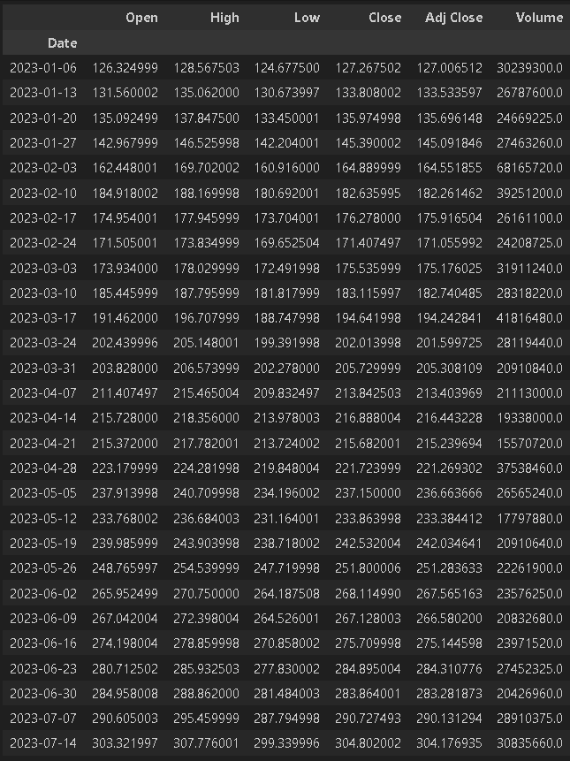

In this example, we retrieved the weekly average, and the labels or indices are dates that fall on Fridays. Note: The screenshot is a snippet of the full output.

Downsampling: Aggregating data to a regular, lower frequency. The data we are aggregating does not need to be fixed frequently; the desired frequency defines the bin edges used to slice the time series for aggregation. For example, to convert to monthly, use "M" or "BM"; you need to chop the data into one-month intervals. Each interval is said to be half-open; a data point can belong only to one interval, and the union of the intervals must make up the whole time frame. There are a couple of things to think about when using resample to downsample data:
- Which side of each interval is closed?
- How to label each aggregated bin, either with the start of the interval or the end?

- Type the following code in a new code cell and run it to see the output:

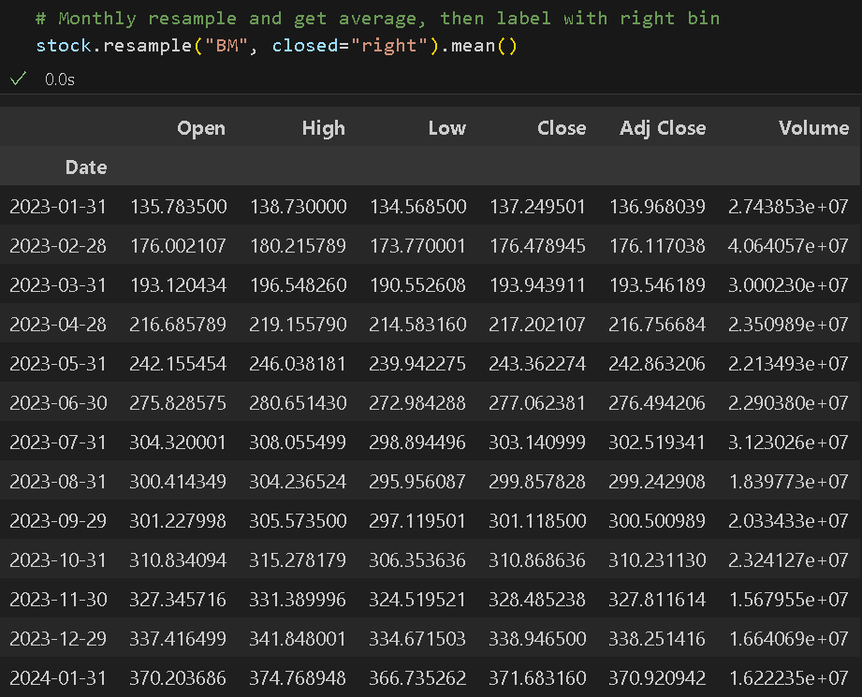

In this example, we have an end-of-business-month frequency and close on the right side of the bin; we then computed the monthly average for each bin interval. Although we did not specify the label, it automatically used the end-of-business-month dates because we specified that in our frequency argument.

- Let us look at another example of downsampling. Type the following code in a new code cell and run it to see the output:

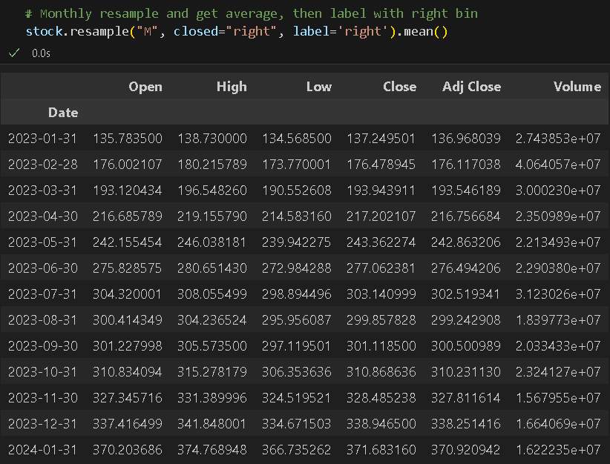

This time, we only specified a monthly frequency and the same proper bin-closing; however, we also added the correct bin label. As you can see, the date indices are slightly different. They do not necessarily fall into a business day.

TO DO:
Try changing the label to ‘left’ and compare the date indices. Because we are computing the monthly mean, the values will not change. Try to calculate the sum for different labels and close settings. Do you notice any changes?

Upsampling and Interpolation
Upsampling is the conversion from a lower to a higher frequency, where no aggregation is required.

- Suppose you wanted to fill forward each 4-hour value. The same filling or interpolation methods are available in the fillna method, and the reindex method is available for resampling. Type the following code in a new code cell and run it to see the output:

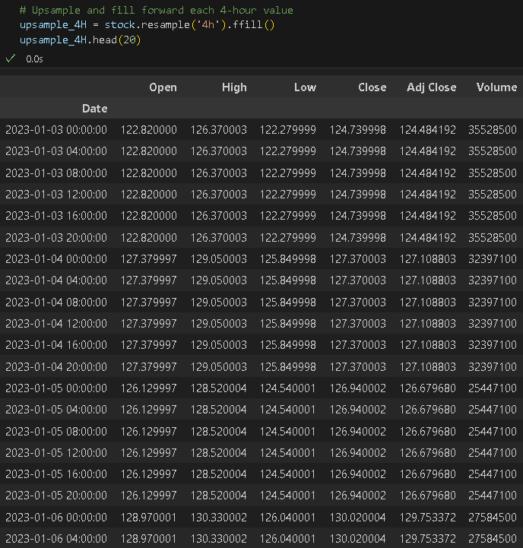

Take note of the datetime indices and the values. Remember, our original data is the daily stock price of Meta. In this example, we created a new DataFrame with a fixed 4-hour frequency and forward-filled the missing times.

- Let us try another example, but this time, we will resample with an annual period (December). Type the following code in a new code cell and run it to see the output:
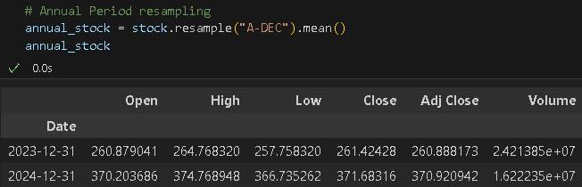

Moving Window Functions: An important class of array transformations used for time series operations is statistics and other functions evaluated over a sliding window or with exponentially decaying weights. This can be useful for smoothing noisy or gappy data, which is quite common in stock data. To accurately analyze stock data and make a sound decision, noise and gaps must be accounted for. Like other statistical functions, moving window functions also automatically exclude missing data.
  - Rolling operator – behaves similarly to resample and groupby. The window argument specifies the number of periods.

- Let us try to compute the 10-day moving average of our stock data. Type the following code in a new code cell and run it to see the output:

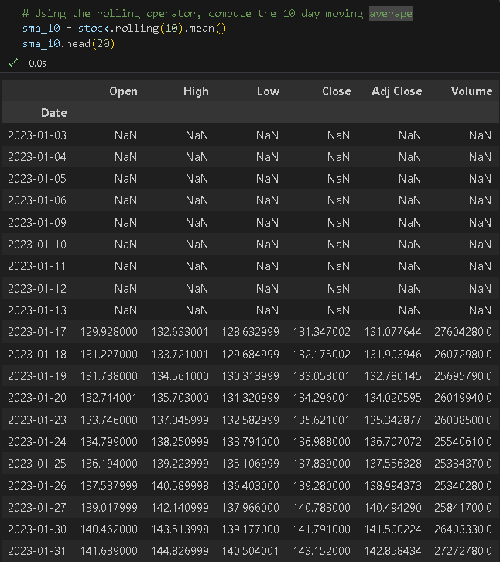
As you can see, the first 10 timestamps now have NaN values. For demonstration purposes, let us leave them as is, but in most cases, we either drop these rows or fill them.

- Looking at the numbers is good, but having visuals of the time series data is better. Now, let us plot our 10-day moving average. Type the following code in a new code cell, then run to see the results.

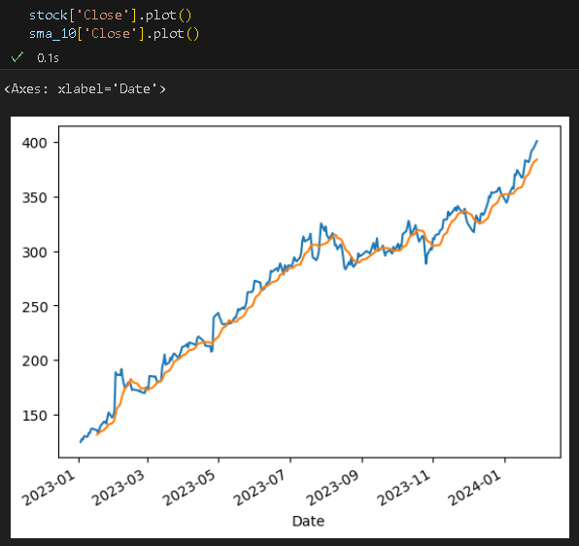

Instead of plotting the entire DataFrame, we are only plotting the values on the ‘Close’ column of each DataFrame. The blue line shows the noisy, gappy original ‘Close’ price, while the orange line shows the smoothed 10-day moving average of the ‘Close’ price.

  - pct_change() – calculates the percentage change between the current and prior data in the series.

- Now, let us compute the 10-day moving average of the stock data’s percent change and the standard deviation. Type the following code to a new code cell then run to see the results.
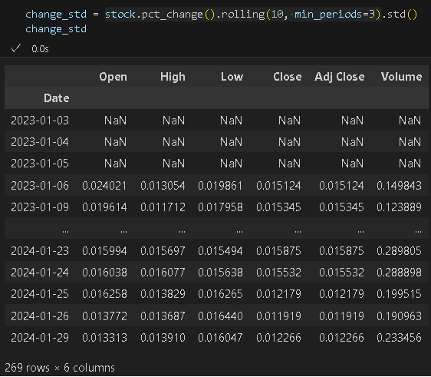

- Then, let us plot the result of the computation. Type the following code to a new code cell then run to see the results.

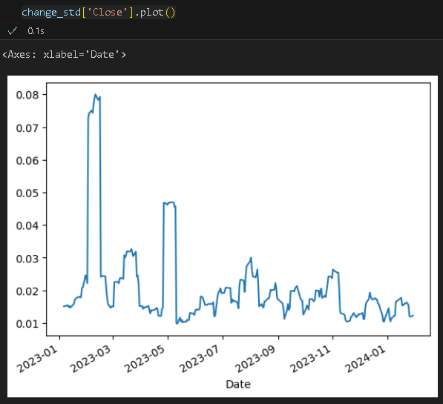
  - expanding() – this computes an expanding window mean. Expanding mean starts the time window from the same point as the rolling window and increases its size until all data points are included.

- Now, let us compute the expanding average of the stock data’s percent change standard deviation. Type the following code in a new code cell, then run to see the results:

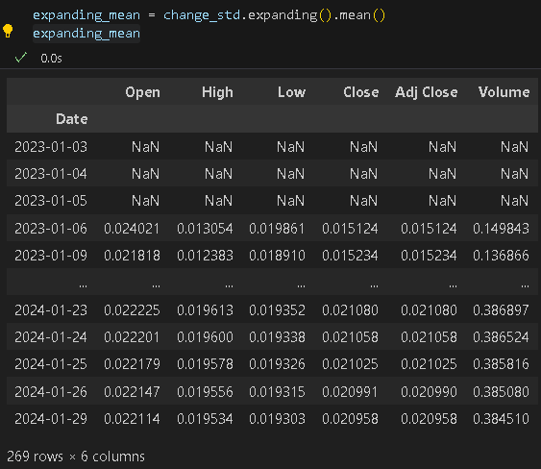

When we computed the percent change and its standard deviation, we indicated a minimum period of 3; therefore, when we calculate the resulting DataFrame’s expanding mean, it will also carry over the minimum period setting. Look at the first three rows and compare them to the change_std output.

- Then, let us plot the result of the computation as well as the percent change and standard deviation together. Type the following code in a new code cell, then run to see the results.
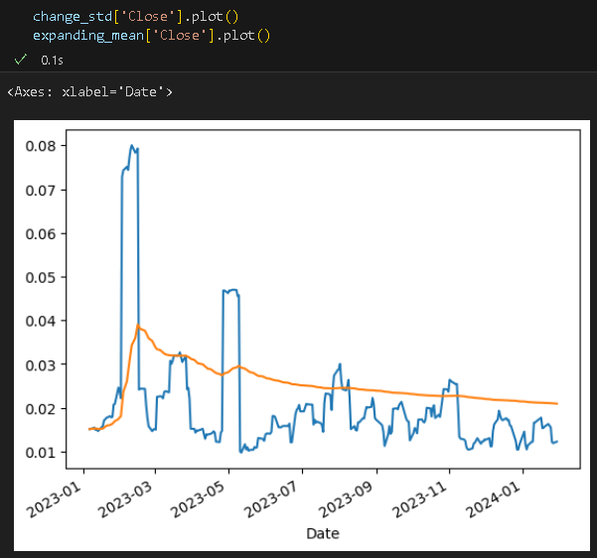

The blue line is the ‘Close’ price’s percent change standard deviation, while the orange line is the expanding mean of the ‘Close’ price’s percent change standard deviation. As expected, the latter is much smoother than the prior.

d. ewm() – operator for exponentially weighted moving average - exponentially weighted moving average – the computation of the average places more weight on the more recent data and can adapt faster to changes.

- Let us compute the exponentially weighted moving average with a span and a window size of 10. Type the following code into a new cell, then run to see the results:
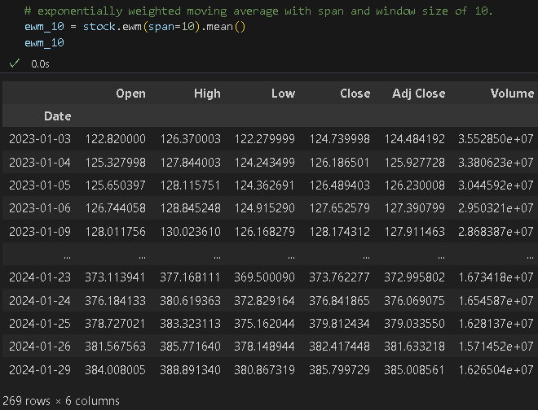

- Let us compare the original ‘Close’ data, the 10-day simple moving average, and the 10-day exponentially weighted moving average of the ‘Close’ column by plotting them. Type the following code into a new cell, then run to see the results:

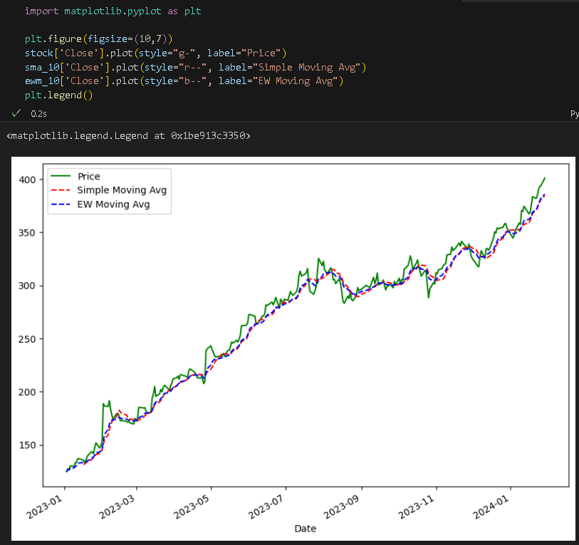
In this exercise, we only covered the basics and the practical use of both Python’s and Pandas tools for time series data. If you are further interested in learning more, here is a link to Panda’s official documentation page on time series data: https://pandas.pydata.org/docs/getting_started/intro_tutorials/09_timeseries.html

*** This is the end of the HOS10A exercise. Please answer HOS10B in Brightspace after pushing your work to GitHub. ***

Push your work to GitHub.
Follow the instructions on the CityU STC TA Center Github.io Submit your work page.
You may also follow the instructions below:

- Open the cmd terminal for Windows users,
- After selecting the + button, make sure the terminal is cmd if you have not closed the Python terminal. If the terminal is not cmd, open the drop-down box and select the Select Default Profile option.
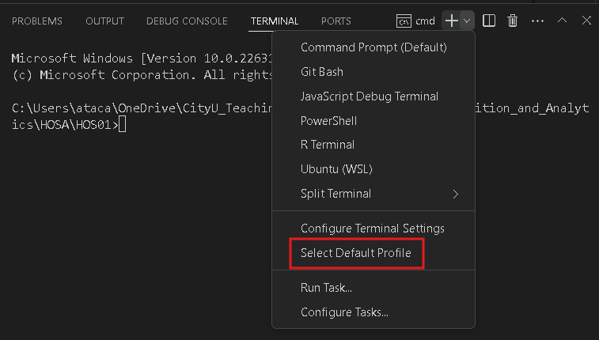

Look for and then select Command Prompt.
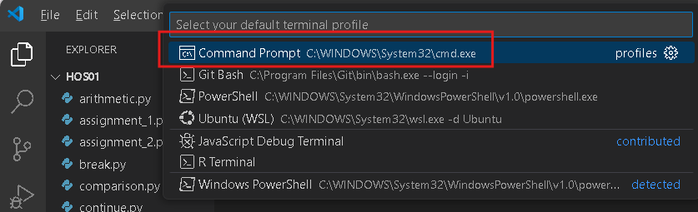

Click the + button. The command prompt will open.

- Make sure you are in the correct directory/repository: Desktop/DS522/hos09a-courseName-yourUserName. Run the following commands to push your work to the GitHub repository:
- Open the terminal from VSCode by hitting the control + ~ key and type the following command:
>>> git add .
>>> git commit -m “Submission for HOS07A-1.”
>>> git push

